SWARM-EX COMMs Personal Goals Report
Prepared By Justin Le
October 5, 2026

Summary of End of Semester Goals and Deliverables
As the COMMs lead for SWARM-EX this semester, my main technical work is on the satellite side of the UHF link, getting Hydra to communicate with the Lithium-2 (Li-2) radio through the CDH board. Both the Simulated Communications Test (SCT) and the Command Execution Test (CET) depend on this link, and both are needed for the SWARM-EX Pre-Integration Review (PIR) in early 2027. The major technical milestones I seek to achieve this semester are completing the Minimum Communications Test (MCT), SCT-1, and SCT-2, along with verifying the ground station PC in the comms chain.
MCT verifies that commands sent from Hydra go through CDH and are received correctly by the Li-2 over UART. SCT-1 is a hardwired test between CDH and Hydra with no RF, where each opcode is checked for the correct command and response following the SYS 105 SCT procedure. SCT-2 then adds the Li-2 and the SDR, with the Li-2 hardlined through attenuators into the SDR and decoded through GNU Radio into Hydra. For SCT to pass, it needs a command success probability above 90%, at least 9600 bps on uplink and downlink, verified CCSDS uplink encryption, and link closure in both directions. SCT-3 and CET readiness are stretch goals for the semester, since they build directly off of SCT-2.
Prof. Palo is taking the lead on developing the ground station PC, and I am responsible for verifying it in the comms chain. This means verifying that the USRP connects to GNU Radio, that GNU Radio and Hydra are able to pass packets to each other, and that the PC works with the existing ground station hardware before it is used for SCT-2. Along with this, I will be onboarding new COMMs members and tracking the work being done across the team.
For my personal goals, I want to become comfortable developing in Hydra, since a lot of the SWARM-EX COMMs work depends on it and there are few people left who know it well. This includes building out the Li-2 command dictionary and understanding how Hydra packetizes commands. I also want to understand the SWARM-EX packet chain from end to end, from the CCSDS packets Hydra sends, to how CDH handles them, to the AX.25 framing that the Li-2 adds. I also want to build embedded debugging skills with UART, logic analyzers, and the CDH firmware. Lastly, as COMMs lead I want to get better at scoping and tracking work for a team, and leave behind documentation that the next team can actually use.
The documents I am responsible for this semester are:
- Weekly quad charts, which report my accomplishments, issues impeding progress, plan for the week, and upcoming deliverables.
- My personal waterfall chart, which tracks my tasks, estimated and actual hours, and status against the semester schedule.
- STIG Ground Station PC: Status, Issues & Path Forward, which tracks the status of the STIG ground station PC as it is developed. It covers the current configuration, open issues and what is being done about them, the options being considered, open questions, and who is involved, so that Prof. Palo, IT, and COMMs are on the same page about where the PC is at.
- A ground station PC verification checklist and its results, listing the checks the PC needs to pass before it is used in the comms chain for SCT-2.
- Updates to the MCT documentation, so that it matches how the test is run with Hydra, CDH, and the Li-2.
- SCT-1 and SCT-2 test records, which are as-run copies of the SYS 105 SCT procedure recording any deviations, the command and response results, Hydra logs, and pass/fail against the SCT success criteria.
- Notes on Hydra and packet handling for SWARM-EX, covering the Li-2 opcode dictionary, the packet structure, and how Hydra strips the AX.25 framing for SWARM-EX unlike MAXWELL.
- The COMMs portion of the mid-semester and end-of-semester reviews.
- A COMMs end-of-semester transition document for next semester's team, with the important COMMs documents and an explanation of each, the team members, and where each work item was left off.
- My final report, documenting what I accomplished this semester against these goals.

Approach
For the Hydra to Li-2 link, I am approaching this from the bottom up, verifying one interface at a time so that when something fails it can be traced back to a single link. I first verify what is coming out of the computer, then what reaches the Li-2, and then what goes through CDH, using a logic analyzer on the UART lines at each step. Part of this is working with CDH to make sure the commands coming from Hydra match what the CDH code expects. The SCT tiers follow the same idea, where SCT-1 is the hardwired CDH to Hydra link, SCT-2 adds the Li-2 and SDR, and SCT-3 adds the antenna, so each tier only adds one new set of hardware.
Each test in my waterfall chart is broken into reviewing the test documents, bench setup and verification, Hydra development, a practice run-through, the full run, and troubleshooting. Setup and the actual test are planned on separate days, where the first day is spent laying everything out on the bench and verifying the hardware, power, and connections, and the test is run on another day. The reason for this is to catch wiring and configuration problems before the test, and to leave time for rework if something goes wrong.
The main software I am using is Hydra for commanding and telemetry. I am working off of the latest working SWARM-EX backup and editing the command dictionary and packetization files, using hardline mode for bench testing and radio mode for SCT-2. On the hardware side, the Li-2 is on its breakout board and powered from a bench supply at 10.0 V with a 0.80 A current limit, with a 30 dB attenuator or antenna always connected. Changes on the CDH side are made in the CDH firmware in MPLAB IDE and flashed with a PICkit, which I work on together with CDH since the UART assignment and command parsing are on their side. For SCT-2, GNU Radio and the USRP SDR on the ground station PC are used for the ground side, starting from the MAXWELL flowgraph with its deframer adjusted for the SWARM-EX Li-2 framing. For references, I am using the SYS 105 SCT Procedure, the MAXWELL SCT-1 and SCT-2 procedures and Hydra guide, the Hydra hardline and radio mode test documents, and the Li-2 user and interface manuals.
With Prof. Palo leading development of the ground station PC, I will be verifying it in the chain with the same bottom up approach. This means checking the USRP to GNU Radio first, then GNU Radio to Hydra, and then the whole ground side with the existing station hardware. I plan on agreeing with Prof. Palo early on what SCT-2 needs from the PC, so verification can start on each piece as it comes up instead of waiting for the finished machine. Progress and open issues on the PC are tracked in the STIG ground station PC status document.
As COMMs lead, I track progress weekly with my waterfall chart, quad charts, and a COMMs action items list. When something is blocked, I bring it up with whoever is needed, whether that is CDH, Prof. Palo, or previous COMMs members.

Schedule
My schedule for the semester is shown in the waterfall chart in Table 1. The technical tasks are ordered by the SCT tiers, since each test depends on the link verified in the test before it. Each test is also broken down into smaller tasks as described in the approach, which is why most tasks are short and spread across weeks.
MCT is planned to finish the week of 10/5. SCT-1 follows, with reviewing the test documents the week of 10/5, bench setup and Hydra development the week of 10/12, and the practice run, full run, and troubleshooting the week of 10/19. Ground station PC work runs alongside SCT-1 from 10/12 to 10/26, since SCT-1 does not need the ground station but SCT-2 does. These tasks will be updated in the waterfall chart to reflect my role of verifying the PC in the chain. SCT-2 then runs from 10/26 to 11/30, starting with reviewing the procedure and developing Hydra for SCT-2, then re-verifying the Hydra to Li-2 link and the ground station setup, with the practice and full run the week of 11/16. Troubleshooting and the post-test documentation review are the week of 11/30, after Thanksgiving week where no work is planned.
For documentation, the mid-semester review prep is the week of 10/26, the end-of-semester review is the week of 12/7, and the final report draft and final are the weeks of 11/30 and 12/14. In total I have estimated 278 hours for the semester, with 129 hours technical, 62 hours documentation, and 87 hours for class and meetings. This is 38 hours over the 240 hour target, mostly due to splitting each test into separate setup and test days, and I plan on re-balancing this once MCT and SCT-1 give a better idea of how long a test actually takes.

Table 1: Personal waterfall chart for SWARM-EX COMMs, Fall 2026.
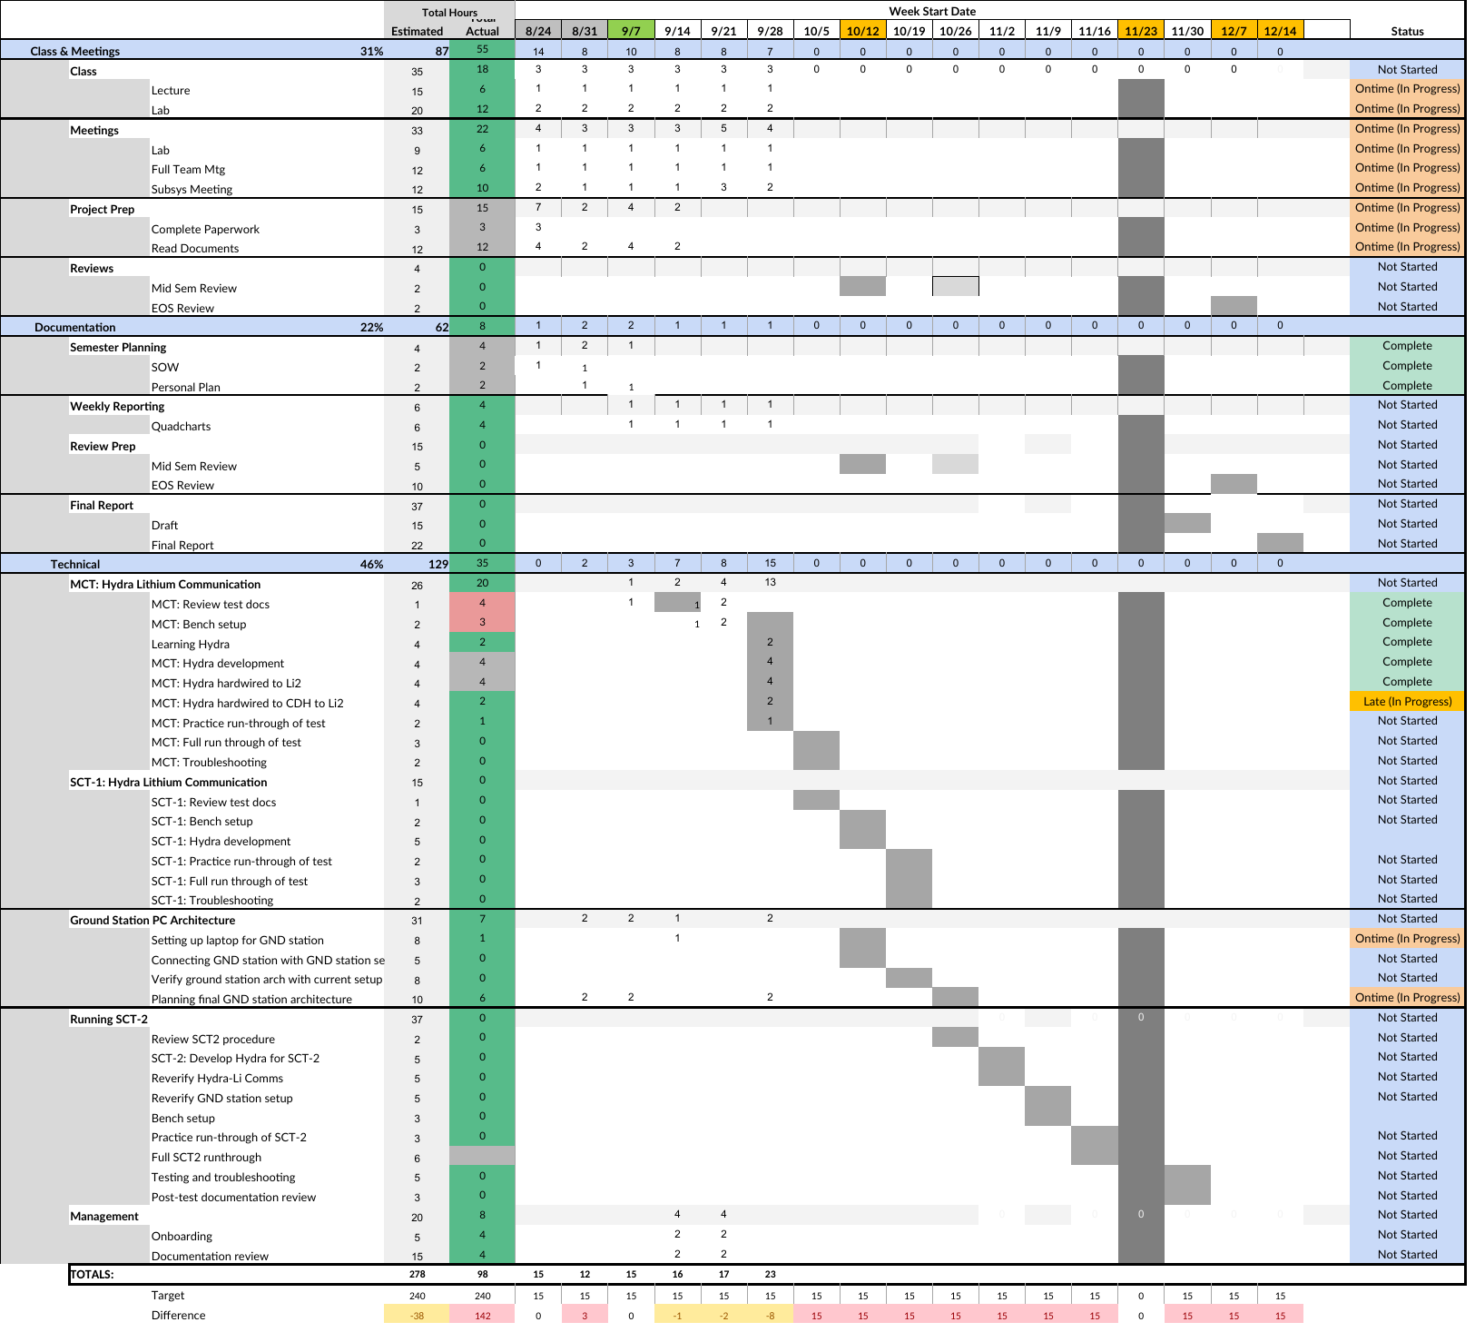

Risks
The main technical risks for my tasks are listed in Table 2, ranked by consequence and likelihood before mitigation. Risks 1 and 2 are the most important since they are directly on the critical path, where risk 1 blocks every test after MCT and risk 2 blocks the ground side of SCT-2. Both start at a likelihood of 4, since these are areas that have had problems before. Mitigation lowers the likelihood of both but not the consequence, since the tests still cannot run if the link or the ground station is not ready. Risk 3 has the highest consequence since there is only one Li-2 radio, but following the bench procedures keeps the likelihood low.
Outside of the table, there is also a programmatic risk with MAXWELL's February delivery possibly pulling ground station hardware, attenuators, and people away from SWARM-EX, which I am keeping an eye on through the weekly all hands meetings.
Table 2: SWARM-EX COMMs technical risks and mitigation strategies.
Note: C/L = Consequence and Likelihood, from the NASA 5x5 risk matrix. Values in the table are before mitigation, with post-mitigation values given at the end of each mitigation strategy.
Rank  C/L | Risk Element and Description | Mitigation Strategy / Consequence
No 1:  4,4 | CDH misinterpreting commands from Hydra, from a mismatch in the command format such as byte order, command length, or the CCSDS header. | Work with CDH to compare the command format the CDH code expects against what is captured on the logic analyzer, test Hydra builds with and without the CCSDS header, and document the agreed packet structure. Impact: MCT cannot be completed, which blocks SCT-1, SCT-2, and CET. (Post-mitigation 4,2)
No 2:  4,4 | Ground station PC not verified in time for SCT-2. Development is led by Prof. Palo, so the schedule is outside of my direct control. | Agree early with Prof. Palo on what SCT-2 needs from the PC, verify each link as it comes up instead of all at the end, and keep an interim laptop setup as a fallback for SCT-2. Impact: SCT-2 cannot be run end to end. (Post-mitigation 3,2)
No 3:  5,2 | Damaging the Li-2 radio during bench testing, from over-voltage, transmitting with no load, or a pinout mistake on the breakout board. | Follow the Li-2 setup instructions (10.0 V, 0.80 A current limit), keep a 30 dB attenuator or antenna connected at all times, and check the pinout during bench setup before powering on. Impact: there is only one Li-2 available, so losing it stops all radio testing and crosslink work. (Post-mitigation 5,1)
No 4:  3,4 | Lack of COMMs documentation. Knowledge such as the packet structure, SWARM-EX AX.25 handling, and ground station PC history was mostly held by previous members. | Use the MAXWELL SCT and Hydra references, follow up with Dhruva and Adhi while they are still available, and document findings as I go. Impact: rework and slower debugging, mostly in SCT-2 when Hydra and GNU Radio first need to connect. (Post-mitigation 2,3)
No 5:  3,3 | RF level and frequency mismatch in SCT-2. Too little attenuation can overwhelm the SDR, and the Li-2 shifts in frequency when hot. | Measure the attenuation chain and check the received power at the SDR during bench setup, and set the GNU Radio RX offset to account for the Li-2 frequency shift. Impact: packet drops or no lock in GNU Radio, failing the SCT success criteria. (Post-mitigation 3,1)

The C/L values for each risk before and after mitigation are shown in Figure 1. After mitigation, risks 1 through 3 move from red to yellow, and risks 4 and 5 move from yellow to green.
Pre-mitigation |  |  |  |  |  |  |  | Post-mitigation
Likelihood | 5 |  |  |  |  |  |  | Likelihood | 5
Likelihood | 4 |  |  | 4 | 1,2 |  |  | Likelihood | 4
Likelihood | 3 |  |  | 5 |  |  |  | Likelihood | 3 |  | 4
Likelihood | 2 |  |  |  |  | 3 |  | Likelihood | 2 |  |  | 2 | 1
Likelihood | 1 |  |  |  |  |  |  | Likelihood | 1 |  |  | 5 |  | 3
 |  | 1 | 2 | 3 | 4 | 5 |  |  |  | 1 | 2 | 3 | 4 | 5
 |  | Consequence |  |  |  |  |  |  |  | Consequence
Figure 1: Stoplight chart of risks before (left) and after (right) mitigation.

